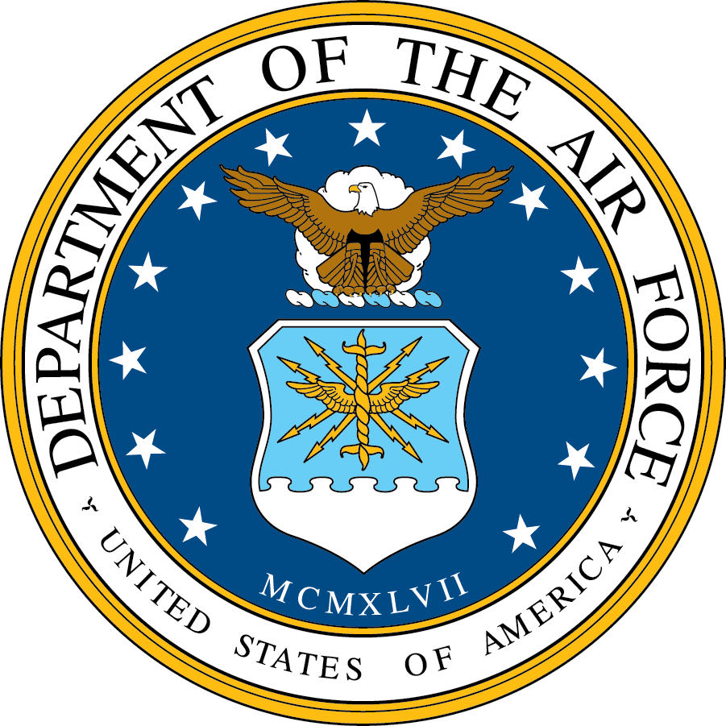
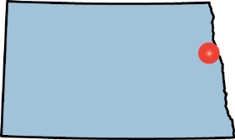
Base Fact Sheet

Grand Forks AFB,
North Dakota

MAJCOM/LOCATION/SIZE: Air Combat Command installation 16 miles west of Grand Forks consisting of 5,773 acres.

MAJOR UNIT/FORCE STRUCTURE:
Weapon Systems | PAA
RQ-4 | 14

- 319th Air Base Wing
- 69th Reconnaissance Group (ACC)
USAF Manpower Authorizations
Total Govt Forces | 1,900
Military
Active/AGR | 1,560
Reserve | 9
Guard | 0
Civilian | 322
Contractor Mnpwr Equivalents | 91

- Airspace/Range Initiatives: N/A

- Distance to Primary Training Range: RQ-4 aircraft typically train in high-altitude (FL500-FL590) Air Traffic Control Assigned Airspace (ATCAA) units extending throughout the northern portion of North Dakota. MQ-1 aircraft from the Air National Guard’s 178th Reconnaissance Squadron utilize Restricted Areas R-5402 (47 nm), R-5403A/B/C (37 nm), and R-5403D/E/F (41 nm).

INFRASTRUCTURE SUMMARY:
  Runway | Width | Length | Material
  17/35 | 150’ | 12,351’ | Asphalt/  Concrete
  Installation Site Picture
  Total Apron Space | 0.74M SY
  Runways | 0.2M SY
  Taxiways | 0.2M SY
  Facility Sq Footage | 3.1M SF
CONSTRUCTION SUMMARY:
  5-Year MILCON Funding Profile
   | FY13 | FY14 | FY15 | FY16 | FY17 | Total
  # | 0 | 0 | 0 | 0 | 0 | 0
  $M | 0 | 0 | 0 | 0 | 0 | 0
  Current MILCON
  None | $0M
FYDP MILCON
Total Program (FY17-21) | $0M
None | $0M

INSTALLATION INFORMATION:

- Encroachment Concerns:
- Installation Complex Encroachment Management Action Plan (ICEMAP) completed in FY15
- Top encroachment challenges include:
  - Security/Safety: Bakken oil transport on nearby rail line poses incident response challenges and mission interruptions in the event of a mishap
  - Spectrum: Expanding wind energy development will interfere with digital airport surveillance radar-11 air traffic control radar and radar services, as well as, the local next-generation weather radar

Public-Public/Public-Private Partnership Initiatives:
- Completed agreements with Grand Forks City include: Increase joint fire department activities; Partner to coordinate mosquito control and Intergovernmental/Cooperative Agreement for Public Works
- Priority partnerships undergoing further development include:
  - Joint use maintenance of Small Arms Firing Range

Privatized Family Housing:

Privatized Housing
Grouped Project | Northern Group
# of units | 547
Year of Project Award | 2013
Privatized Owner | BBC
*Project is still in the IDP.

Enhanced-Use Leasing EUL Initiatives: On 18 Feb 2015, the EUL site Development Lease was signed between the Air Force and Grand Forks County. On 30 March 2016 an Airport Joint Use Agreement was signed granting Grand Sky Park operational permission to use the Grand Forks AFB runway. The first official flight from Grand Sky Park using the Grand Forks AFB runway occurred on 28 July 2016.

Major Energy Initiatives: Numerous projects are on-going, converting interior/exterior fixtures to LED, executing retro-commissioning activities throughout many facilities, and the replacement and upgrade of inefficient HVAC units.

- Major NEPA Actions: KC-46A MOB 4 Beddown

CODEL INFORMATION:

Sen Heidi Heitkamp (D) Sen John Hoeven (R) Rep Kevin Cramer (R)
