DESCRIPTION OF PROPOSED ACTION AND ALTERNATIVES
FOR
THE TEMPORARY MOVEMENT OF B-1B AIRCRAFT AND FLIGHT OPERATIONS
TO GRAND FORKS AFB, NORTH DAKOTA

PREPARED BY:
28 CES
28 CES/CEIEN, Ellsworth AFB, South Dakota

29 July 2024

Table of Contents

LIST OF ABBREVIATIONS / ACRONYMS 3
LIST OF FIGURES 4
LIST OF TABLES 5
CHAPTER 1: PURPOSE OF AND NEED FOR THE PROPOSED ACTION 6
1.1 INTRODUCTION 6
1.2 LOCATION OF THE PROPOSED ACTION 6
1.3 PURPOSE OF AND NEED FOR THE PROPOSED ACTION 7
1.4 DECISION TO BE MADE 7
1.5 APPLICABLE REGULATORY REQUIREMENT AND INTERGOVERNMENTAL COORDINATION 7
1.5.1 Interagency and Intergovernmental Coordination 7
1.5.2 Other Regulatory Requirements 8
CHAPTER 2 DESCRIPTION OF THE PROPOSED ACTION AND ALTERNATIVES 9
2.1 SELECTION STANDARDS 9
2.2 DESCRIPTION OF SCREENING ALTERNATIVES 10
2.2.1 Alternative 1: Proposed Action (Preferred Alternative) 10
2.2.2 Alternative 2: Relocation to Lincoln Airport, NE 17
2.2.3 Alternative 3: Relocation to Dyess AFB, Texas 18
2.2.4 Alternative 4: No Action Alternative 18
2.3 ALTERNATIVES CONSIDERED BUT ELIMINATED FROM FURTHER CONSIDERATION 18

LIST OF ABBREVIATIONS / ACRONYMS

AFI | Air Force Instruction
ARPA | Archaeological Resources Protection Act
BW | Bomb Wing
CFR | Code of Federal Regulations
CEQ | Council on Environmental Quality
EAFB | Ellsworth Air Force Base
ESA | Endangered Species Act
EA | Environmental Assessment
EIAP | Environmental Impact Analysis Process
EIS | Environmental Impact Statement
EO | Executive Order
FONSI | Finding of No Significant Impact
GFAFB | Grand Forks Air Force Base
MBTA | Migratory Bird Treaty Act
NE | Nebraska
NEPA | National Environment Policy Act
ND | North Dakota
NHPA | National Historic Preservation Act
PRTC | Powder River Training Complex
PL | Public Law
RW | Reconnaissance Wing
SD | South Dakota
TX | Texas
U.S.C. | United States Code

LIST OF FIGURES

Figure 2-1. Proposed Action Area …………………………………………………………….12
Figure 2-2. Proposed Facility Use at Grand Forks AFB……………………………………….13
Figure 2-3. Area of Potential Effect for the temporary relocation of B-1B aircraft to GFAFB..16
Figure 2-4. Flight patterns from Grand Forks AFB to Powder River Training Complex ……..17

LIST OF TABLES

Table 2-1. Proposed Facilities for aircraft, personnel, munitions and equipment storage………14
Table 2-2. Personnel from 28 BW stationed at GFAFB by month during relocation……………15
Table 2-3. Screening of Alternatives ………………………………………………………….…19

CHAPTER 1: PURPOSE OF AND NEED FOR THE PROPOSED ACTION

  - INTRODUCTION

The runway at Ellsworth Air Force Base (EAFB), South Dakota will be closed for repairs for approximately ten months from February through November 2025. In order to ensure continuity of operations, the 28 Bomb Wing (BW) at EAFB must operate from an alternative airfield during the closure period. An Environmental Assessment (EA) is being prepared to evaluate any potential environmental impacts which may result from the temporary relocation of aircraft, equipment, munitions and personnel from EAFB.

The Proposed Action would temporarily relocate approximately seventeen (17) B-1B aircraft, 1,000 personnel, munitions and support equipment to Grand Forks AFB (GFAFB), ND, for approximately 10 months. The Proposed Action would occur during the period that EAFB’s runway is closed for repairs.

The 1969 National Environmental Policy Act (NEPA), as amended, requires federal agencies to consider environmental consequences in their decision-making process. The President’s Council on Environmental Quality (CEQ) has issued regulations to implement NEPA that include provisions for both the content and procedural aspects of the required environmental impact analysis. The Air Force Environmental Impact Analysis Process (EIAP) is accomplished through adherence to the procedures set forth in CEQ regulations (40 Code of Federal Regulations [CFR] §§1500-1508) and 32 CFR §989 (Air Force Environmental Impact Analysis Process). These federal regulations establish both the administrative process and substantive scope of the environmental impact evaluation designed to ensure that deciding authorities have a proper understanding of the potential environmental consequences of a contemplated course of action.

A Notice of Availability (NOA) for the Draft EA and FONSI, will be published in Forum of Fargo-Moorhead and Grand Forks Herald. Copies of the Draft EA and unsigned Draft FONSI will be made available at the Grand Forks Public Library in Grand Forks, ND. These documents will also be made available on the internet at the https://www.grandforks.af.mil/About-Us/Economic-and-Environmental-Information/. At the same time, copies of the Draft EA and FONSI/FONPA will be distributed to federal, state, and local agencies and applicable Federally recognized Native American Tribes. Copies will also be provided to any other individuals or organizations upon request during the public review period. Applicable and relevant comments received will be addressed in the Final EA.

- LOCATION OF THE PROPOSED ACTION
GFAFB is in Grand Forks County in North Dakota. The City of Grand Forks is approximately 15 miles to the east of the base and the town of Emerado, ND is to the southeast. The area surrounding the base and airfield is rural and has a low population density.

PURPOSE OF AND NEED FOR THE PROPOSED ACTION
The CEQ regulations implementing the NEPA require that an EA specify the underlying purpose of and need to which an agency is responding in proposing actions and alternatives (40 CFR 1502.13). The purpose of the Proposed Action is to ensure that there is no interruption in the mission of the 28 BW. The 28 BW is the Air Force lead B1-B conventional bomb wing and provides critical rapid deployment and long-range strike capabilities around the world. The 28 BW operates two of three squadrons of B-1Bs and must maintain routine operations to ensure military readiness. The 28 BW needs to operate from an alternative airfield while runway repairs are completed between February and November 2025 at EAFB.

DECISION TO BE MADE
The EA will evaluate the potential environmental consequences associated with the Proposed Action to temporarily relocate B-1B aircraft, operations, and personnel to GFAFB for approximately 10 months of operation. Based on the analysis in the EA, DAF will make one of three decisions regarding the Proposed Action (32 CFR 989.14(a)).
1. Determine the Proposed Action and alternatives would have no significant environmental impacts and issue a signed Finding of No Significant Impact (FONSI).
2. Initiate preparation of an Environmental Impact Statement (EIS) if it is determined that implementing the Proposed Action or alternatives would result in significant environmental impacts.

3. Select the No Action Alternative, whereby the Proposed Action would not be implemented.

As required by NEPA and CEQ regulations implementing NEPA (40 CFR Parts 1500 - 1508), preparation of an environmental document must precede final decisions regarding a federal proposed action and be available to inform decision-makers of the potential environmental impacts.

APPLICABLE REGULATORY REQUIREMENT AND INTERGOVERNMENTAL COORDINATION

Interagency and Intergovernmental Coordination
The DAF EIAP, in compliance with NEPA, requires opportunities for the public and agencies to review information relevant to the Proposed Action and alternatives. NEPA also requires federal agencies to consider the effects of their proposed actions in accordance with relevant environmental laws and regulations including Section 7 of the Endangered Species Act (ESA) and Section 106 of the National Historic Preservation Act (NHPA). Consultation with the US Fish and Wildlife Service (USFWS) and National Marine Fisheries Service is required, as applicable, to comply with Section 7 of the ESA.

Government-to-government consultation between the DAF and Native American tribes having historic, cultural, or religious ties to areas where the Proposed Action will be conducted in accordance with the National Historic Preservation Act (NHPA) (54 U.S.C. § 300101, et seq) and its implementing regulations at 36 CFR Part 800 which requires federal agencies to consult with Federally Recognized Tribes on proposed undertaking that have the potential to effect
Consistent with the NHPA, the Native American Graves and Protection and Repatriation Act (25 USC § 3001 et seq.), US Department of Defense Instruction 4710.02, Interactions with Federally Recognized Tribes, and DAFI 90-2002, Air Force Interaction with Federally Recognized Tribes, the Air Force will consult with federally recognized tribes that are historically affiliated with lands in the vicinity of the Proposed Action and Alternatives to consult on all proposed undertakings that have a potential to affect properties of cultural, historical, or religious significance to the tribes. The tribal consultation process is distinct from NEPA consultation and requires separate notification to all relevant tribes. The timelines for tribal consultation are also distinct from those of NEPA consultation. The Grand Forks point of contact for Indian tribes is the Base Commander. The point of contact for consultation with the Tribal Historic Preservation Officer and the State Historic Preservation Officer (SHPO) is the Grand Forks AFB Cultural Resources Manager.

Other Regulatory Requirements
EA considers all applicable laws and regulations, including but not limited to the following:
- NEPA of 1969 (Public Law [PL] 91-190, 42 United States Code [U.S.C.] §4321-4347)
- 32 CFR §989, Environmental Impact Analysis Process
- 40 CFR §1500-1505, CEQ’s Regulations on Implementing NEPA
- 50 CFR §402, Interagency Cooperation - Endangered Species Act of 1973, as amended
- U.S. Army Corps of Engineers wetlands policy
- Endangered Species Act (ESA) of 1973 (16 U.S.C. §1531-1542)
- Migratory Bird Treaty Act (MBTA) of 1918 (16 U.S.C. §703-712; Ch. 128; July 13, 1918; 40 Stat. 755)
- Archaeological Resources Protection Act (ARPA) of 1979
- National Historic Preservation Act (NHPA) of 1966 (36 CFR §800)
- Native American Graves Protection and Repatriation Act of 1991 (25 U.S.C. §3001 et seq.)
- Executive Order (EO) 11988 - Floodplain Management
- EO 11990 - Protection of Wetlands
- EO 12898, Federal Actions to Address Environmental Justice in Minority Populations and Low-Income Populations
- Air Force Manual (AFMAN) 32-7003, Integrated Natural Resources Management
- AFMAN 32-7003, Cultural Resources Management
- AFI 32-7066, Environmental Baseline Surveys in Real Property Transactions
- Clean Air Act of 1970 (42 U.S.C. §7401 et seq.)
- AFMAN 32-7002, Air Quality Compliance and Resource Management
- United States Air Force Air Quality EIAP Guide found online at http://aqhelp.com.
- Clean Water Act of 1972 (33 U.S.C. §1251 et seq.)
- Pollution Prevention Act of 1990 (42 U.S.C. §13101 and §13102 et seq.)
- Air Force Air Quality EIAP Guide – Fundamentals, Volume 1 of 2
- Considering Cumulative Effects under the National Environmental Policy Act, Council on Environmental Quality, January 1997
- CEQ document “Environmental Justice, Guidance Under the National Environmental Policy Act”
- Air Force Guide for Environmental Justice Analysis under the EIAP

CHAPTER 2 DESCRIPTION OF THE PROPOSED ACTION AND ALTERNATIVES

This section provides detailed information on the Proposed Action and Alternatives, including the No Action Alternative. As discussed in Section 1.4, the NEPA process is used to evaluate potential environmental consequences associated with a Proposed Action and consider alternative courses of action. Reasonable alternatives must satisfy the purpose of and need for a Proposed Action, as defined in Section 1.3. In addition, CEQ regulations also specify the inclusion of a No Action Alternative against which potential effects can be compared. While the No Action Alternative would not satisfy the purpose of or need for the Proposed Action, it is analyzed in accordance with CEQ regulations.

SELECTION STANDARDS
Identifying and analyzing alternatives is one of the core elements NEPA and the Air Force’s
implementing regulations. The Air Force may expressly eliminate alternatives from detailed analysis based on reasonable selection standards (32 CFR 19 §989.8[c]). This section describes the Air Force process and the application of this process to identify alternative temporary runway locations. The process applied operational and other criteria to identify reasonable alternatives for the temporary relocation of B-1B aircraft.

Viable options for the alternative runway location must satisfy the following selection criteria:

- Adequate Runway length and width requirements
- Capability to operate seventeen (17) B-1B at one airfield
- Existing capability and infrastructure to allow for receipt, issuance, loading and storage of supplies, including munitions
- Capability/capacity to accommodate servicing and maintenance requirements, including fueling of aircraft.
- Capacity to accommodate 1,000 people to the local area
- Distance from EAFB to GFAFB for logistical support to minimize resources needed and distance for training operations in the PRTC

DESCRIPTION OF SCREENING ALTERNATIVES
NEPA and the CEQ regulations mandate the consideration of reasonable alternatives for the Proposed Action. Reasonable alternatives are those that could be used to meet the purpose of and need for the Proposed Action. Among the alternatives evaluated is a No Action Alternative, which evaluates the potential consequences of not undertaking the Proposed Action and serves to establish a comparative baseline for analysis. The following alternatives including the No Action Alternative were identified and screened against the selection standards.

Alternative 1: Proposed Action (Preferred Alternative)
Under the Proposed Action, GFAFB would provide the 28 BW with ramp, runway space, operational facilities and munition storage and loading areas needed to operate from an alternative runway location during the time the EAFB runway is closed (Figure 2-1). Based on the selection standards described above, GFAFB was the only installation that met the minimum requirements necessary for the proposed temporary relocation of aircraft. The Proposed Action would allow the 28 BW to continue its mission without disrupting the mission of the 319th Reconnaissance Wing (319 RW) at GFAFB. The 319 RW currently oversees the infrastructure and support for the unmanned RQ-4 missions across the globe.
The Air Force proposes to temporarily relocate 17 B-1B aircraft, support operations, equipment, munitions and up to 1,000 personnel in order to satisfy the Purpose and Need for the Action described above. B-1B aircraft operated out of GFAFB until 1994; however, they no longer have the operational personnel, equipment, supplies or munitions to adequately support the 28 BW. The 28th BW will supply personnel, munitions, equipment and supplies to limit impacts to 319 RW operations.
Pending completion of any required environmental assessment and pending availability of funding, preparation for the proposed action would begin prior to flight operations. Movement of munitions and equipment would occur as early as October 2024. Movement of the aircraft would occur in December 2024 and January 2025. Actual flight and training operations would not begin until 1 February 2025.
The operation of the B-1B aircraft and associated personnel would use a combination of new and existing structures for operations, maintenance, storage of supporting equipment and munitions. Existing buildings, or portions of buildings, have been identified for use or shared use with the 319 RW and include: B520, B521, B522, B556, B601, B603, B605, B607, B609, B613, B633, B661, B668, and B670 (Figure 2-2). Additionally, six (6) munition storage structures are available for use include 739, 740, 743, 744, 745 and 746 (Figure 2-2).
The temporary relocation will require construction of up to three temporary hangars for aircraft maintenance which will be installed on the Charlie Ramp (Figure 2-2). Power to the hangars will be supplied by generator or connecting to the Grand Forks AFB power system. Minor modifications and repairs of available facilities selected for use for aircraft, operations, maintenance and support activities may be required. Preparation of infrastructure and the movement of munitions and equipment would be completed in a phased approach starting in November of 2024, if approved, and funding becomes available. Expected facility use and required modifications to the buildings are in Table 2-1. Personnel would be housed off-base in hotels and available rental apartments. Personnel from the 28 BW would begin arriving in December and reach full staffing by April of 2025 (Table 2-2).
Flight operations would increase at GFAFB by up to four (4) landings and takeoffs (LTOs) per day. Operation of aircraft would use the existing flight path routings and operating hours that GFAFB currently uses for departures and arrivals at the airfield. B-1B training operations would continue to use the PRTC airspace. The relocation of B-1B aircraft to GFAFB will result in approximately 900 additional flight operations during the EAFB runway closure. The Area of Potential Effect of the proposed action includes the airfield, the area under the B-1B noise contours, the flight path to the PRTC and buildings that will be used to support B-1B operations (Figure 2-3, Figure 2-4).

Fig 2-1. Proposed Action Area
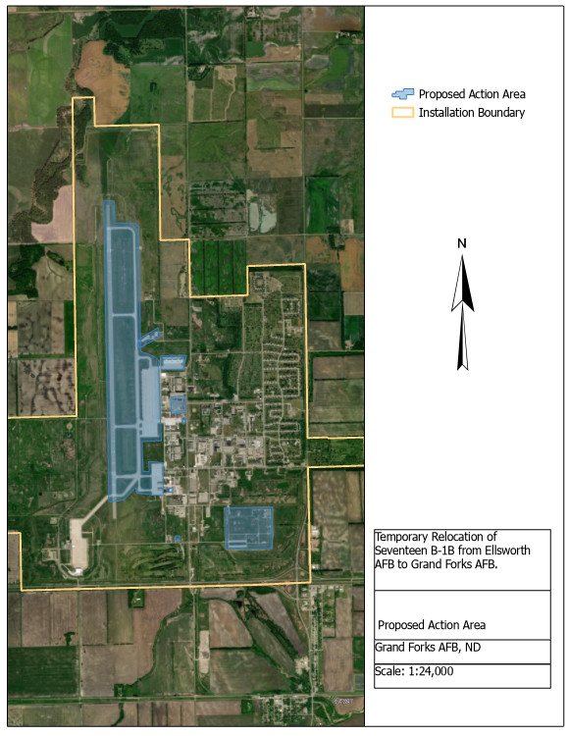

Figure 2-2. Proposed Facility Use at Grand Forks AFB
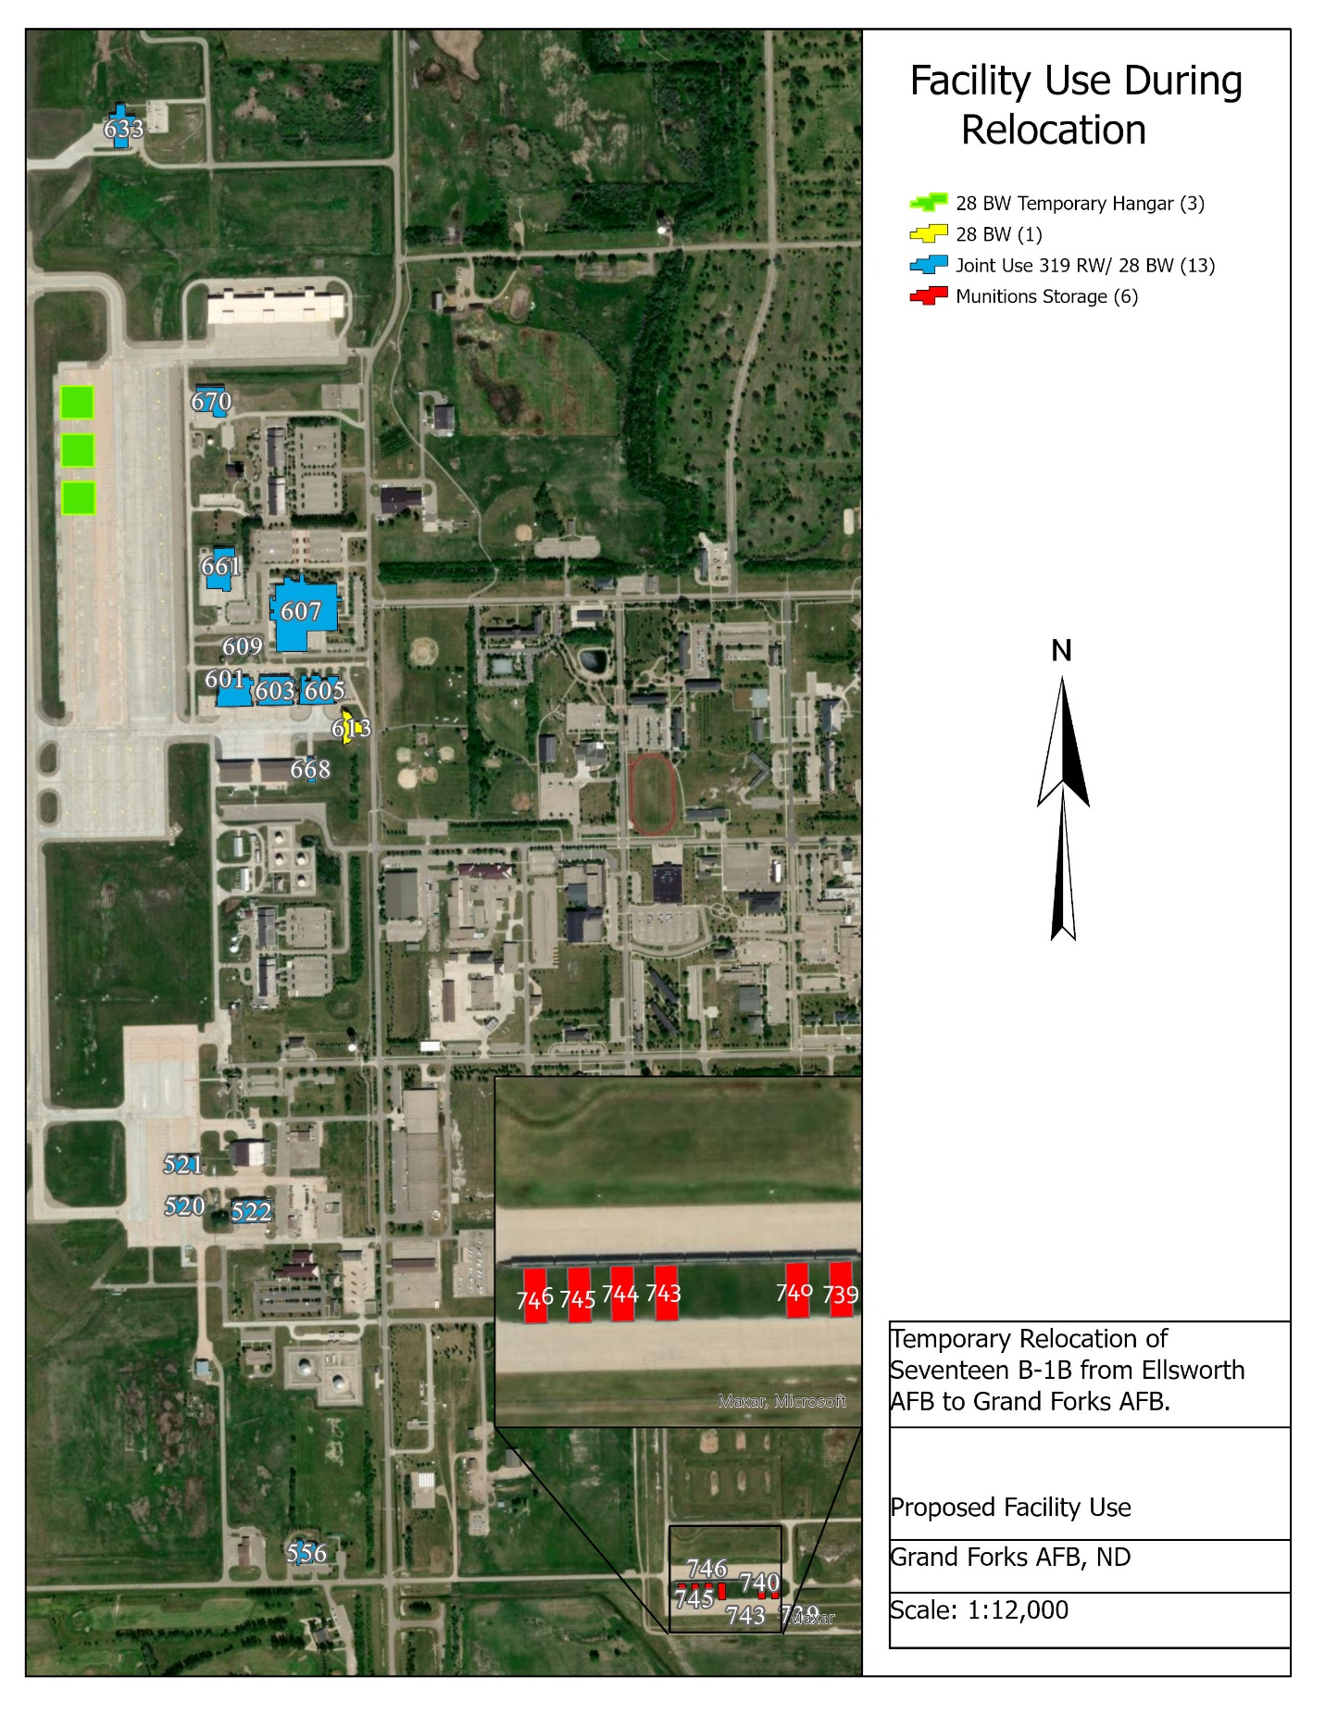
Table 2-1. Proposed Facilities for aircraft, personnel, munitions and equipment storage
Existing Buildings | Intended Use | Modifications
520 | Snow Removal and Deicing Equipment- Joint use with 319 RW
521 | Snow Removal and Deicing Equipment- Joint use with 319 RW
522 | Portion of hangar available for LRS vehicles. Joint use with 319 RW Pavements Maintenance Facility.
556 | Operations and Mission Planning Office Space/Air crew flight equipment storage. Joint use with 319 RW | HVAC Repair  Electrical Repair
601 | Hangar- joint use with 319 RW
603 | Hangar -joint use with 319 RW
605 | Hangar -joint use with 319 RW
607 | Joint Use with 319 RW- Office Space
609 | Joint use with 319 RW
613 | Hangar | Hangar Door Modification for B1 Maintenance
633 | Fire Station- Fire truck and 10 personnel from EAFB to assist GFAFB Fire Department
661 | Joint use with 319 RW- 2 Bays for AGE storage
668 | Equipment Storage- CTK
670 | LRS Part Storage and Supply
739 | Munition Storage- 75% of space available
740 | Munition Storage
743 | Munition Storage
744 | Munition Storage
745 | Munition Storage
746 | Munition Storage
New Construction
Temporary Hangar (3) | Aircraft Maintenance | New Construction- Two options for power supply. Connection to existing power at GFAFB or generator supply.

Table 2-2. Personnel from 28 BW stationed at GFAFB by month during relocation
Month | 28 BW personnel on station at GFAFB
December | 30-50
January | 450-500
February | 450-500
March | 450-500
April-November | 800-1000

Figure 2-3. Area of Potential Effect for the temporary relocation of B-1B aircraft to GFAFB
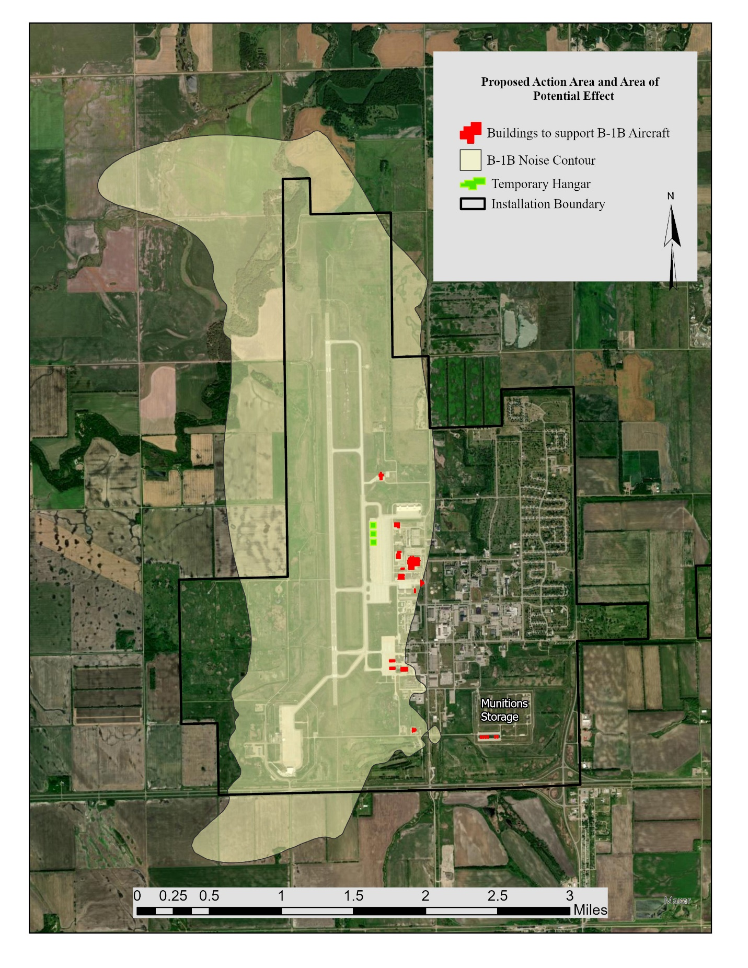
Figure 2-4. Flight Patterns from Grand Forks AFB to Powder River Training Complex
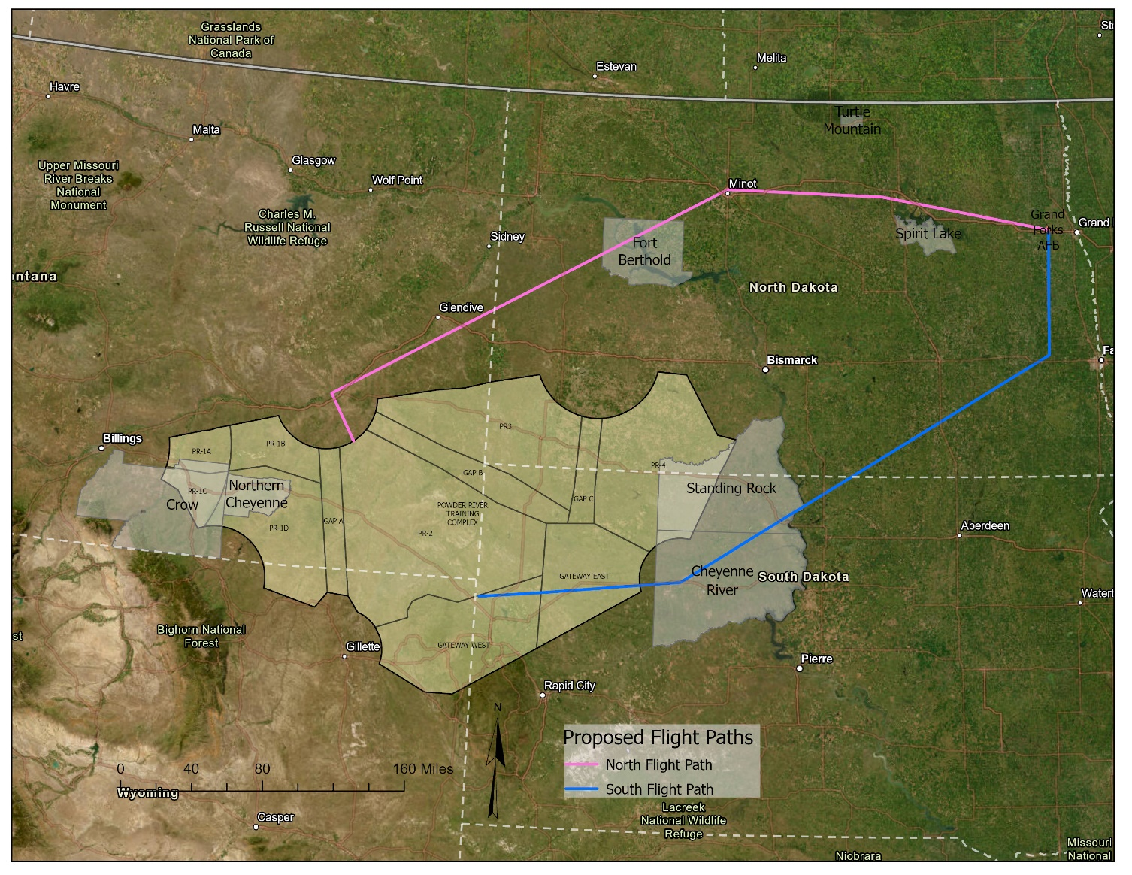

Alternative 2: Relocation to Lincoln Airport, NE
EAFB would temporarily relocate 17 B-1B aircraft, operations and personnel from EAFB to Lincoln Airport in Lincoln, NE.
Alternative 2 meets four of the six selection standards. The distance to Lincoln Airport (508 m) is shorter than the distance to GFAFB (529 m); however Lincoln Airport does not have the required fuel capacity to support B-1B bomber operations or the capability to store and load/unload munitions. Therefore, Alternative 2 was eliminated from further analysis.

Alternative 3: Relocation to Dyess AFB, Texas
EAFB would temporarily relocate 17 B-1B bombers, personnel, munitions, and equipment from EAFB to Dyess AFB for a period approximately 10 months.
Alternative 3 meets three of the six selection standards. Dyess AFB does not have the capacity to provide sufficient space to land and operate 17 additional B-1B bombers. The travel distance from EAFB to Dyess AFB is 978 miles which increases cost of transferring equipment, munitions, personnel and parts to and from EAFB during the closure. Concrete spalling limits airfield space use and increases runway conflict with the Dyess AFB required mission and operation. The limited number of refueling pits would also impact mission requirements. The distance from EAFB would increase transportation cost of equipment and personnel during the relocation period. Flight distance to the PRTC for training purposes would increase. Therefore, Alternative 3 was eliminated from further analysis.

Alternative 4: No Action Alternative
The CEQ regulation, 40 CFR §1502.14(d), requires the inclusion of a No Action Alternative in the NEPA analysis. Under the No Action Alternative, the Air Force would not temporarily relocate 17 B-1B aircraft and operations from EAFB to GFAFB but would instead ground the aircraft until runway repairs have been completed at EAFB. The No Action Alternative will serve as the baseline for the evaluation the Proposed Action and alternative for adverse impacts to the affected environment. The effected environment and environmental resources analyzed in the EA will be discussed in Chapter 3 of the draft EA.

ALTERNATIVES CONSIDERED BUT ELIMINATED FROM FURTHER CONSIDERATION
Three locations were considered by EAFB for the temporary beddown of the B-1B and include GFAFB, ND, Lincoln Airport, NE and Dyess AFB, TX. Site visits were conducted in 2024 to determine base compatibility for the temporary relocation. GFAFB was the only base that met the selection criteria for the purpose and need for the proposed action. A comparison of standards is provided in Table 2-3.

Table 2-3. Screening of Alternatives
Alternative | Runway Length/Width Requirements | Capability to operate 17 B-1B at one airfield | Capability/ Capacity for receipt, issuance, loading and storage of supplies, including munitions | Capability/ Capacity to service, maintain and fuel aircraft | Capacity to House 1,000 Personnel | Distance/Proximity to EAFB and PRTC
Alternative 1 – GFAFB  (Preferred Alternative) | Y | Y | Y | Y | Y | Y
Alternative 2- Lincoln Airport | Y | Y | N | N | Y | Y
Alternative 3- Dyess AFB | Y | N | Y | N | Y | N
No Action Alternative

